***Experiment 10 Output***

**Aim:** This experiment sets up a Continuous Integration/Continuous Deployment (CI/CD) pipeline using GitHub Actions, Docker, and LocalStack to simulate AWS services.

***Initialising a git repo***

***Creating S3 Bucket and Storing data***

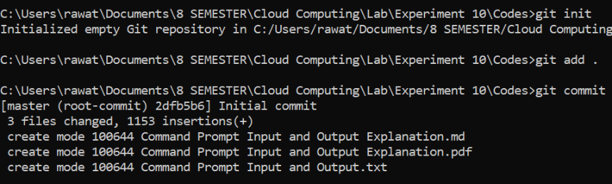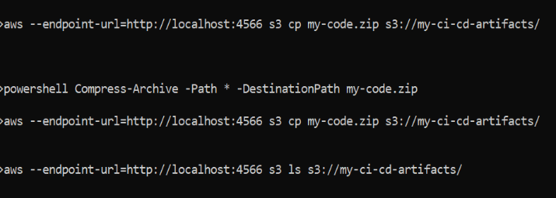

***Fig 2: Git Repository Intitialization***

**Fig 1: S3 Bucket**

***Updating in Remote Repository***

***Pulling the Remote Repository***

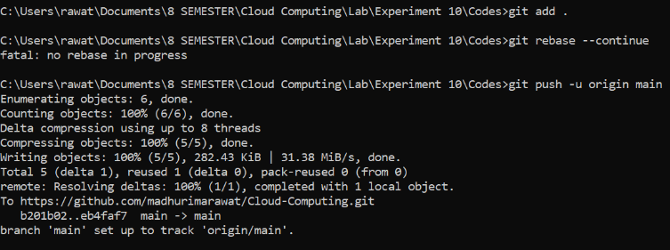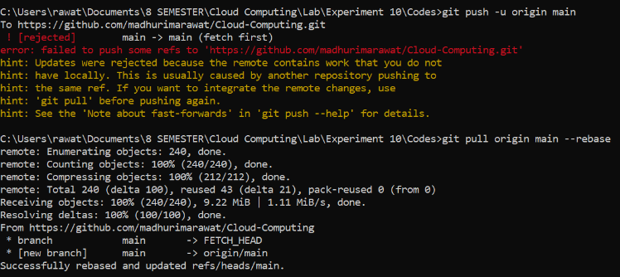

**Fig 4: Updating in Repository**

***Remote Repository and Workflow***

**Fig 3: Remote Repository**

***Workflow Run***

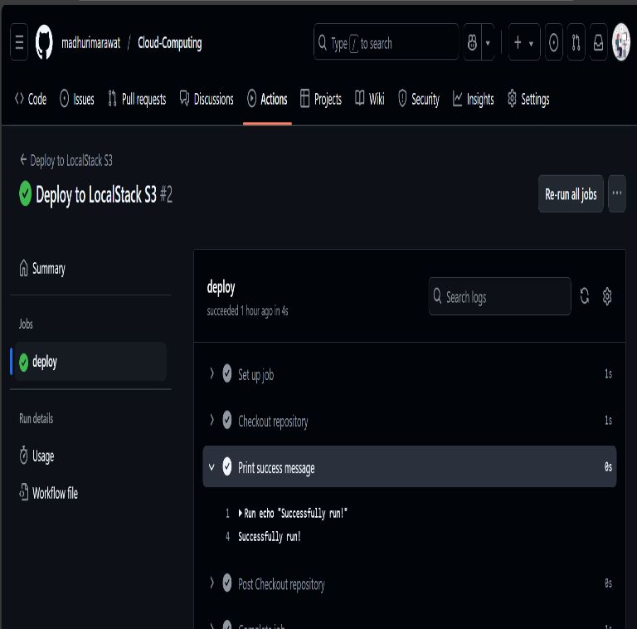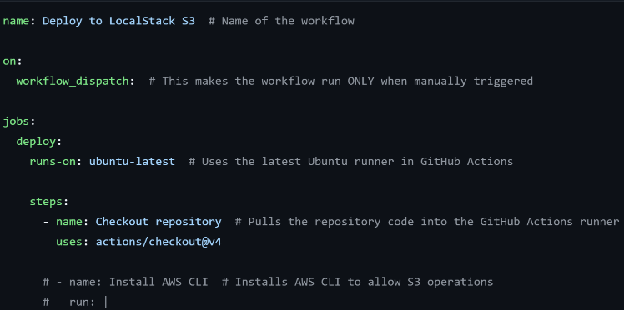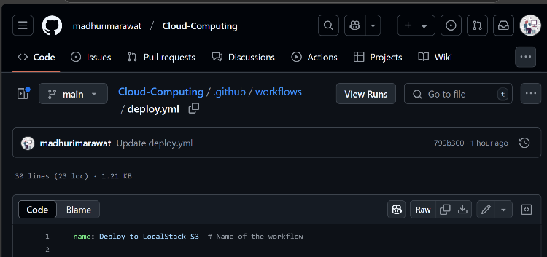

***Fig 5: Remote Repository and Workflow File***

***Fig 6: GitHub Actions Workflow***